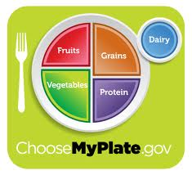
Planet Power Daily Grade
Students are to Blast Off successfully to Planet Power. Using the following link or internet directions (choosemyplate.gov, click under Professionals tab below labeled Teachers/Educators, and then click on Blast Off Game)! http://www.fns.usda.gov/multimedia/Games/Blastoff/BlastOff_Game.html
Please print off the Certificate that your child has successfully picked a healthy day of activity and meals! If you are not able to make it to Planet Power, please print off the Report instead. If you are not able to print, please return this paper with a written explanation with a parent signature! Have Fun!

