1920's Radio Broadcast Project
The students will be researching a person or event from the
1920’s, recording their voice by reading their information into a
recorder, and recording facts from all of the research from the
entire class.
This project has 4 parts:
- Individual research
- Creating a script from the research
- Recording of research through voice recording
- Listing facts from the entire playback of all research
from the class
Process: Students will pick a name “out of the hat” and research
using books from the library and internet. The students will
record information on the back of this sheet. From that sheet, the student will write their script about their person the 1920’s to record on a recorder. They can make it funny or just like a “news break.” Once all recordings have been made, all students will write one fact from each person represented as the “project is “broadcasted” back to the students.
This is an in and out of class project, and students can print off research from home to bring to class to work on it at certain times!
Points: 75 (25- research 25- script- 25- recording and writing facts from broadcast)
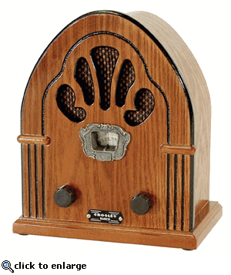
This research (from home, library, and school mobile laptops) and script are due, Monday, Dec. 8! Recording and playback will be the following several days of class!

