Name __________________ (Partner): ___________________
****Use the Concise ANIMAL Encyclopedia
Mammals Poster Project
Rodents (Pages 251-257)
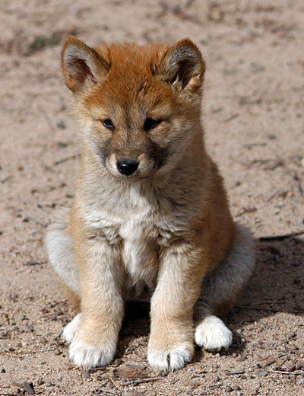
Bears (pages 268-269)
Dogs (pages 264-265)
Foxes (pages 266-267)
Primates (pages 242-249)
Marsupials (pages 231-235)
Bats (Pages 241-242)
Whales/Dolphins/Porpoises (pages 258-263)
Cats (Pages 276-279)
Insectivores (pages 236-239)
Seals, Sea Lions, and Manatees (pages 280-281)
Horses/ Rhinoceroses (pages 284-285)
Pigs, Peccaries, Hippos (Pages 286-287)
Deer (pages 290-293)
Giraffes and Okapi (page 294)
Antelope/Cattle, Buffalo/Bison (pages 295-303)
Categories (Must be on Poster)
Characteristics
Regions of the World
Size
Lifespan
Interesting Facts

