Mammals Project
Students are to collect information about their chosen mammal (chosen in class from the Top 50 List from arkive.org) using the internet and any other book sources available. Secondly, students are to find the measurements (length and width in inches) of the mammal and cut the two measurements from a string (thick enough to see), cord, or yarn. Please make sure the two pieces are the same color and are “tagged” (tape) with animal’s name, and whether it is the length or width! Students are to watch some video and pictures of their mammal. Website to use are: arkive.org (***Key website: Go under this website,Explore ARKive, Mammals), and animal.discovery.com.

Due Date: Wednesday, Dec. 17

Points: 100---- 50 facts sheet, 50 measurements

Mammal: ________________________
Facts (The first 2 facts should be the best/coolest facts about your mammal)
- ___________________________________________________________________________ ___________________________________________________________________________
- ___________________________________________________________________________ ___________________________________________________________________________
- ___________________________________________________________________________
- ___________________________________________________________________________
- ___________________________________________________________________________
- ___________________________________________________________________________
- ___________________________________________________________________________
- ___________________________________________________________________________
- ___________________________________________________________________________
- ___________________________________________________________________________

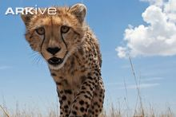

Status
_____________________________________________________________________________________ _____________________________________________________________________________________ _____________________________________________________________________________________ __________________________________________________________________________________________________________________________________________________________________________ _____________________________________________________________________________________ _____________________________________________________________________________________ _____________________________________________________________________________________
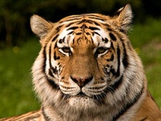
Description
_____________________________________________________________________________________ _____________________________________________________________________________________ _____________________________________________________________________________________ __________________________________________________________________________________________________________________________________________________________________________ _____________________________________________________________________________________ _____________________________________________________________________________________ _____________________________________________________________________________________ __________________________________________________________________________________________________________________________________________________________________________
Range
_____________________________________________________________________________________ _____________________________________________________________________________________ _____________________________________________________________________________________ ____________________________________________________________________________________________________________________________________________________________________________________________________________________________________________________________________________________________________________________________________________________

Habitat
_____________________________________________________________________________________ _____________________________________________________________________________________ _____________________________________________________________________________________ _______________________________________________________________________________________________________________________________________________________________________________________________________________________________________________________________
Biology
_____________________________________________________________________________________ _____________________________________________________________________________________ _____________________________________________________________________________________ _________________________________________________________________________________________________________________________________________________________________________________________________________________________________________________________________________________________________________________________________________________________________________________________________________________________________________
Threats
____________________________________________________________________________________________________________________________________________________________________________________________________________________________________________________________________________________________________________________________________________________ _____________________________________________________________________________________ _____________________________________________________________________________________ __________________________________________________________________________________________________________________________________________________________________________

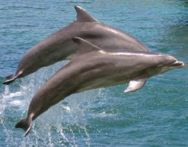

Conservation
_____________________________________________________________________________________ _____________________________________________________________________________________ _____________________________________________________________________________________ _________________________________________________________________________________________________________________________________________________________________________________________________________________________________________________________________________________________________________________________________________________________________________________________________________________________________________

Endangered???
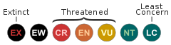 Listing of my mammal by the IUCN: _________________
Check one. Yes ____ No____ I have watched several videos and observed pictures of my mammal.
Length of my mammal: ____________________
Width of my mammal: ____________________

